**SCREENSHOT**

**package** process;

**import** org.apache.commons.io.FileUtils;

**import** java.io.File;

**import** java.io.IOException;

**import** org.openqa.selenium.OutputType;

**import** org.openqa.selenium.TakesScreenshot;

**import** org.openqa.selenium.WebDriver;

**import** org.openqa.selenium.chrome.ChromeDriver;

**import** org.openqa.selenium.chrome.ChromeOptions;

**public** **class** shot {

**public** **static** **void** main(String[] args) **throws** IOException {

// **TODO** Auto-generated method stub

System.*setProperty*("webdriver.chrome.driver","C:/Users/hai/Downloads/chromedriver_win32/chromedriver.exe");

ChromeOptions options = **new** ChromeOptions();

options.addArguments("--remote-allow-origins=*");

//creating obj for web driver

WebDriver driver=**new** ChromeDriver(options);

driver.get("https://www.facebook.com/");

driver.manage().window().maximize();

//creating reference is the first step

TakesScreenshot tk=(TakesScreenshot)driver;

//taking screenshot and storing it in the temporary file

File source=tk.getScreenshotAs(OutputType.***FILE***);

//creating destination file

File des=**new** File("E:\\Software Testing\\screen\\facebook.png");

//moving the file from source to destination

FileUtils.*copyFile*(source, des);

}

}

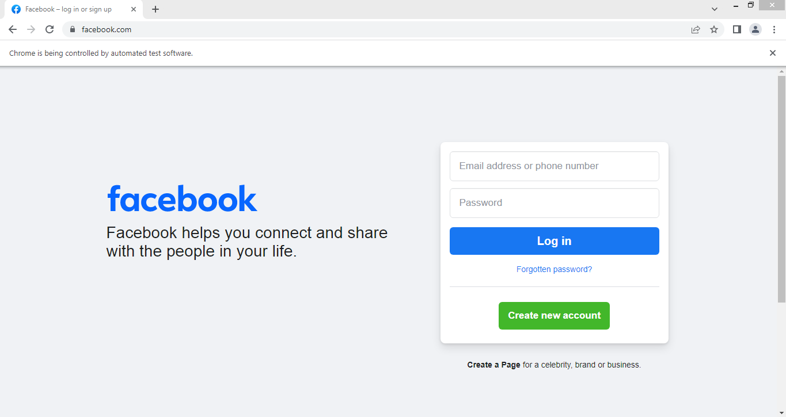

**EXCELSHEET**

package loginexcel;

import org.apache.poi.ss.usermodel.*;

import org.apache.poi.xssf.usermodel.XSSFWorkbook;

import java.io.*;

import java.util.*;

public class excel {

public static void main(String[] args) {

Scanner sc = new Scanner(System.in);

System.out.print("Enter your username: ");

String username = sc.nextLine();

System.out.print("Enter your password: ");

String password = sc.nextLine();

sc.close();

try {

boolean loginValid = isLoginValid("E:/Software Testing/screen/loginexcel.xlsx", username, password);

// Append the result to the output Excel file

writeToResultExcel(loginValid);

if (loginValid) {

System.out.println("Login successful!");

} else {

System.out.println("Login failed!");

}

} catch (IOException e) {

e.printStackTrace();

}

}

public static boolean isLoginValid(String filePath, String username, String password) throws IOException {

FileInputStream file = new FileInputStream(new File(filePath));

Workbook workbook = new XSSFWorkbook(file);

Sheet sheet = workbook.getSheetAt(0);

Iterator<Row> rowIterator = sheet.iterator();

while (rowIterator.hasNext()) {

Row row = rowIterator.next();

Cell usernameCell = row.getCell(0); // username is in the first column

Cell passwordCell = row.getCell(1); // password is in the second column

String storedUsername = usernameCell.getStringCellValue();

String storedPassword = passwordCell.getStringCellValue();

if (storedUsername.equals(username) && storedPassword.equals(password)) {

workbook.close();

file.close();

return true; // Login successful

}

}

workbook.close();

file.close();

return false; // Login failed

}

public static void writeToResultExcel(boolean loginValid) throws IOException {

FileInputStream resultFile = null;

Workbook workbook = null;

try {

// Open the existing result Excel illana it create automatiaclly

File outputFile = new File("E:/Software Testing/screen/result.xlsx");

if (outputFile.exists()) {

resultFile = new FileInputStream(outputFile);

workbook = new XSSFWorkbook(resultFile);

} else {

workbook = new XSSFWorkbook();

}

Sheet sheet = workbook.getSheet("Login Result");

if (sheet == null) {

sheet = workbook.createSheet("Login Result");

}

int lastRowNum = sheet.getLastRowNum();

Row row = sheet.createRow(lastRowNum + 1);

Cell cell = row.createCell(0);

if (loginValid) {

cell.setCellValue("Pass");

} else {

cell.setCellValue("Fail");

}

FileOutputStream fileOut = new FileOutputStream(outputFile);

workbook.write(fileOut);

fileOut.close();

} finally {

if (workbook != null) {

workbook.close();

}

if (resultFile != null) {

resultFile.close();

}

}

}

}

OUTPUT:

Enter your username: renu

Enter your password: renu98

Login successful!

